Register Your Gmail!
- Go to www.gmail.com
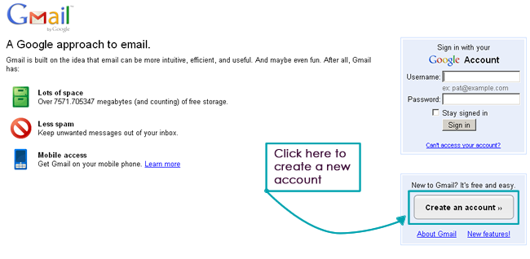
- Create an account

- Make sure your username is your first.last name… your address should look like:
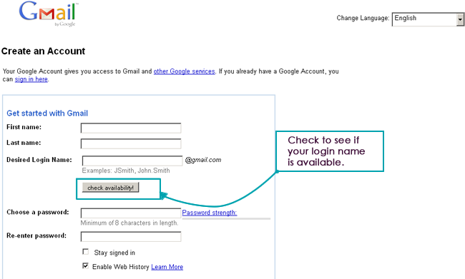
Nicole.cafarelli@gmail.com

- Create a password you will remember that is school appropriate. Example: use your LHS password!
- Create a security question you will remember.
- When you are done, use EDMODO to register on the form. Follow directions from assignment #3 carefully!
raise your hand

If you have any problems or your username is not available

